Magnetic Levitation Train Technology 1

By:

Paul Friend

Project Advisor:

Dr. Anakwa

Date:

May 12, 2004

Bradley University Department of

Electrical and Computer Engineering

ABSTRACT

The objective of this project is the creation of a laboratory scale magnetic levitating train. The reason for choosing the Inductrack method and a basic explanation of the Inductrack method for magnetic levitation are given. The subcategories: Halbach array, Inductrack, and the overall system are explained by design equations, simulations, fabrication, testing methods, and results. Propulsion methods are briefly explained. The conclusion includes a summary of tradeoffs, possible applications, and suggestions for further development of the project.

Table of Contents

Project Summary 1

Maglev Method 1

Subsystems 1

Research 2

Halbach Array 2
Methods of Formation 3
Chosen Formation 3
Simulations 4
Fabrication 4
Validation 5

Inductrack 6
Circuit Theory 6
Methods of Inductracks 7
Array of Inductors 7
Wire Rungs 8
Laminated Sheets 10
Fabrication 10

Maglev System 11
Simulation 12
Design Equations 13
Train Parameters 14
Track Parameters 14
Inductance 14
Resistance 15
Inductrack Maglev System 15
Breakpoint Analysis 19
Transition Analysis 19
Analysis 19
Laminated Sheets 19
Array of Inductors 24
Wire Rungs 25
General Analysis 26
Testing 27
Straight Track 27
Test Wheel 27
Fabrication 27
Results 28

Propulsion 30
Linear Synchronous Motor 30
Linear Induction Motor 30

Conclusion 32
Tradeoffs 32
Applications 32
Propulsion 32
Generators 32
Motors 32
Bearings 32
Suspension 33
Theories 33
Suggestions 34

Equipment 34
Products 34

Patents 35

Acknowledgments 36

Bibliography 37

APPENDIX A – LAMINATED SHEET GUI A1

APPENDIX B – WIRE RUNGS GUI B1

APPENDIX C – ARRAY OF INDUCTORS GUI C1

List of Tables and Figures

Figure 1 – Overall System Block Diagram 1
Figure 2 – Subsystem Block Diagram 2
Figure 3 – Standard Halbach Array Formation 3
Figure 4 – Longer Wavelength Halbach Array Formation 3
Figure 5 – Chosen Halbach Array Formation 4
Figure 6 – Simulated Halbach Array 4
Figure 7 – Constructed Train 5
Figure 8 – Induced Current Waveform by Halbach Array 6
Figure 9 – Modeled Inductrack System 6
Figure 10 – MATLAB Magnitude and Phase Bode Plot 7
Figure 11 – Array of Inductor Inductrack Method 8
Figure 12 – Single Inductor 8
Figure 13 – Square Bulk of Copper Litz-wire 9
Figure 14 – Wire Rungs 9
Figure 15 – Wire Rungs Inductrack Method 9
Figure 16 – Laminated Sheets Inductrack Method 10
Figure 17 – CNC Router Bit 10
Figure 18 – Laminated Copper Sheet 11
Figure 19 – Inductrack System Basic Illustration 11
Figure 20 – Inductrack Maglev System Simulation 13
Figure 21 – Bx & By Components 21
Figure 22 – Laminated Sheets Force Curves 22
Figure 23 – Log Scale Force and Phase Shift 23
Figure 24 – Levitation Height 23
Figure 25 – Drag and Levitation Forces for Array of Inductors 25
Figure 26 – Optimum Magnet Thickness 27
Figure 27 – Maximum Levitation Height and Wavelength 27
Figure 28 – Maglev Test Bench 28
Figure 29 – Magnitude and Phase Shift 29
Figure 30 – Drag and Levitation Forces 29
Figure 31 – Three Phase LSM Propulsion 30
Figure 32 – Standard LIM Based in Track 31
Figure 33 – Propulsion via Modified LIM 31
Figure 34 – Theoretical Static Movement 33
Figure 35 – Theoretical Dynamic Movement 34

Project Summary
The objective of the Maglev Train 1 project is to design and implement levitation, guidance, and propulsion for a small scale train. The project is to be a multiyear project, because the entire system must be created. The individual objectives of the Maglev Train 1 project are as follows:

- Choose a Maglev method
- Determine subsystems
- Research the method
- Design and simulate the Maglev train
- Test the Maglev train
- Develop conclusions

The results are to be compared with Maglev Train 2 to develop an overall conclusion about the Maglev train methods.

Maglev Method
Current forms of Maglev trains in operation require vast amounts of power in order to levitate the train. Dr. Richard F. Post of Lawrence Livermore National Laboratory (LLNL) developed a Maglev method in the late 1990’s called the Inductrack method. The Inductrack method utilizes passive levitation. No external power is needed to levitate the train. The levitation is induced by the motion of the train.

The first laboratory scale train using the Inductrack method was demonstrated in 1998. Dr. Post is currently the head of the Low-Speed Urban Maglev Program under the U.S. Department of Transportation, Federal Transit Administration along with General Atomics (GA), Hall Industries, and many other companies. Creation of a full scale low speed Maglev train is the goal of the program. A test cart and track has been created, but it is still in the development stage.

There are many benefits when using the Inductrack method. As already stated, no external power is needed for levitation. The levitation is induced by the motion of the train. At high speeds, the power required for propulsion is relatively low, because there are no contact frictional forces, and the magnetic drag forces are low. Another benefit of the Inductrack method is it is self stabilizing. This means that complex controls are not needed in order to safely levitate the train by the use of magnets.

Subsystems
The overall system block diagram is shown in figure 1.

Maglev
System
Desired Velocity
Train Velocity
Levitation
Figure 1 – Overall System Block Diagram
The overall system can be placed into two subsystems of levitation and propulsion. The levitation can then be placed further into subsystems of the Halbach arrays and the Inductrack. Propulsion is placed into subsystems of controls, sensing, and the propulsion mechanism. A lower level block diagram is shown in figure 2.

Controller
Desired Velocity
Propulsion
Method
Train Velocity
Sensor
Constant
Induced Current
Induced
Magnetism
Train
Levitation
Levitation
Constant
Figure 2 – Subsystem Block Diagram

The project concentrated on the levitation system of the Maglev train. The levitation can be designed by analyzing the Halbach array, and the Inductrack method.

Research
Since the Inductrack method is new, there is little information available. The main resources used were documents written by Dr. Post about his recent findings. General conversation with Dr. Post proved to be the best source of gathering information. General conversation with Hal Marker of Litz-wire provided information relative to creating the track. An interview with Phil Jeter of GA gave insight on reasons why certain aspects were chosen for the Low-Speed Urban Maglev Program.

Halbach Array
The Halbach array is a special formation of magnets used to direct each individual magnet’s field to create a strong sinusoidal magnetic field below the array while nearly canceling the magnetic fields above the array. The formation was invented by Klaus Halbach for the use of particle acceleration application [2]. The Halbach arrays are placed under the train to provide levitation and guidance.

Methods of Formation
The standard formation using 90 degree angles is shown in figure 3.

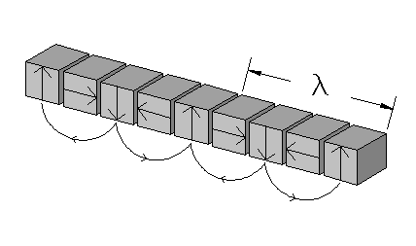
Figure 3 – Standard Halbach Array Formation

The wavelength λ meters, is the distance between each repetitive pattern.

A longer wavelength configuration can be created using the same principles by placing the magnetic fields of the permanent magnets at different angles to create a more directed field [12]. This longer wavelength configuration is shown in figure 4.

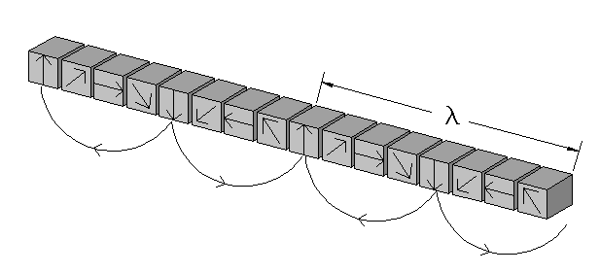
Figure 4 - Longer Wavelength Halbach Array Formation

Chosen Formation
The formation chosen for Maglev Train 1 is the standard Halbach array. Grade 38 Neodymium-Iron-Boron (NdFeB) rare-earth 12 mm cube magnets have also been chosen to be used, because of their high strength. The longer wavelength method would require magnets with their fields directed at given angles to be acquired.

A five magnet Halbach array has been chosen to be used as shown in figure 5.

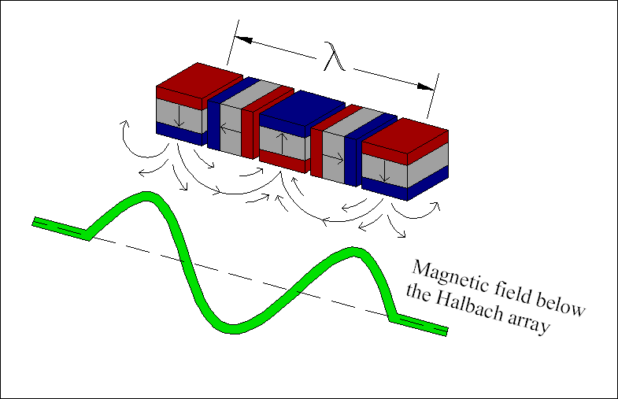
Figure 5 – Chosen Halbach Array Formation

The formation in figure 5 will allow for three points of levitation with the minimum number of magnets used.

Simulations
Vizimag, a magnetic field simulation program has been used to simulate the Halbach array chosen. Figure 6 illustrates the magnetic field lines of the Halbach array.

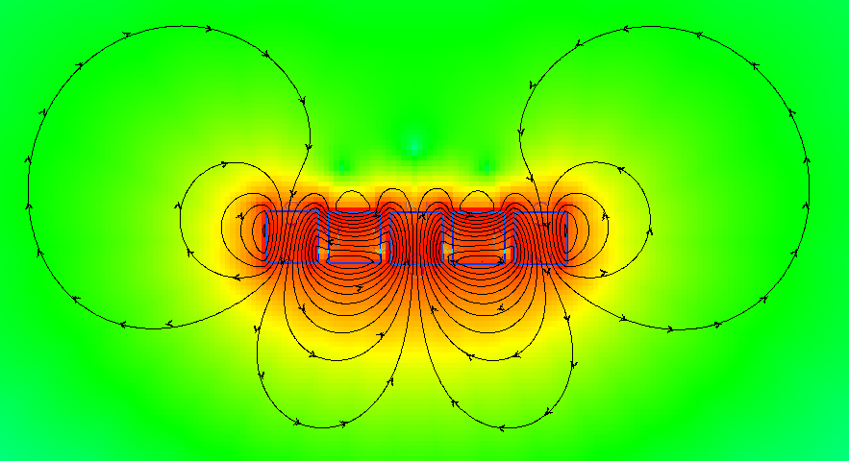
Figure 6 – Simulated Halbach Array

As seen in figure 6, a sinusoidal magnetic field is created below the array. The magnetic field is nearly cancelled above the array. There are fringe effects at the ends of the array, where the field loops around.

Fabrication
The fabricated train uses five Halbach arrays in parallel for levitation, two side Halbach arrays for lateral guidance, and two bottom Halbach arrays for sharp turn guidance. Placing NdFeB magnets into the Halbach formation is very difficult. Materials of wood and aluminum were chosen for construction, because they are nonferrous materials. Figure 7 shows the train created with the Halbach arrays in it.

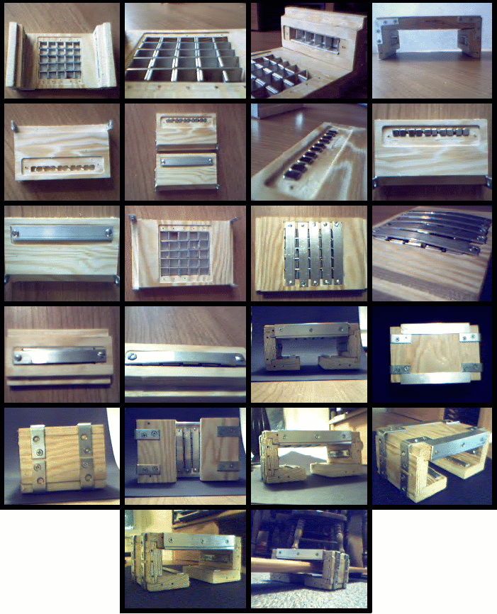
Figure 7 – Constructed Train

It can be seen that the magnets are bowing the aluminum pieces out in the area where the Halbach arrays are located.

Validation
The Halbach array was tested by many methods. One method was that a magnet was placed in a hand and waved below and above the array. The magnet spins very strongly when waved underneath the array. Nearly no magnetic fields are present on the upper side of the array except the fringe fields that can be felt.

Another method of testing the sinusoidal effect of the magnetic field is to wave the Halbach array over a coil of wires. This will induce a current proportional to the magnetic field. A current probe was used to measure the current created. Figure 8 shows the oscilloscope plot of the current waveform obtained.

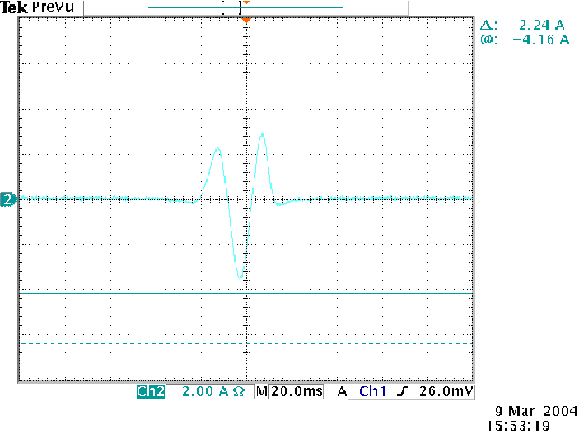
Figure 8 – Induced Current Waveform by Halbach Array

As seen in figure 8, the induced current waveform is proportional to the predicted magnetic field of the Halbach array illustrated in figure 5.

Inductrack
The Inductrack is the name for the track that works with the Halbach array to create the levitation when the train is in motion. The goal of the Inductrack is to create a track that is an inductor, or array of inductors. The inductors must be “separate.” The inductors must also guide the induced current perpendicular to the direction of motion. High drag forces will occur if this is not enforced. The Inductrack must be made to allow enough induced current to create a magnetic field with a great enough magnitude to levitate the train. Also, the goal is to create as much inductance as possible with as low resistance as possible. This allows the train to begin levitating at a lower velocity due to a phase shift in the current. Control theory has been used to explain this concept further.

Circuit Theory
The track can be modeled as an inductor and resistor in series. The Halbach array passing over the track can be modeled as a sinusoidal voltage source. The frequency of the voltage source corresponds to the velocity of the Halbach array. Figure 9 shows the modeled Inductrack system.

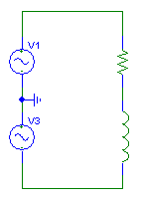
Figure 9 – Modeled Inductrack System

The transfer function from input voltage to coil current is given by

i(s)/v(s) = (1/L)/(s + R/L) (1)

This results in a pole at R/L. This means that the phase will lag by 45º when the frequency reaches R/L. Using MATLAB, the Bode plots of the magnitude and phase are shown in figure 10.

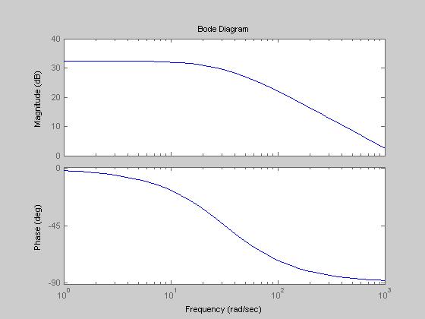
Figure 10 – MATLAB Magnitude and Phase Bode Plot

It can be seen that the phase begins at 0º, begins to shift one decade prior to the R/L pole, reaches -45º at the R/L pole, and then approaches -90º as the frequency increases. Since the phase shift relates to the drag forces becoming levitation forces, it is desired to place the R/L pole as close to the origin as possible. This means that it is desired to achieve the most inductance possible with the least amount of resistance. The lift to drag ratio can be developed by inverting the pole giving

Lift/Drag = ω L/R (2)

It is noted that the induced voltage created by passing the Halbach array over the track is not constant. The induced voltage increases as the velocity increases. This has not been shown, because a zero added at the origin would cause a phase shift of 90º.

Methods of Inductracks
The track can be made by one of three methods. The methods are an array of inductors, wire rungs, and laminated sheets.

Array of Inductors
An Array of Inductors method was utilized to create the first Inductrack at Lawrence Livermore National Laboratory. An illustration of the Array of Inductors method is illustrated in figure 11.

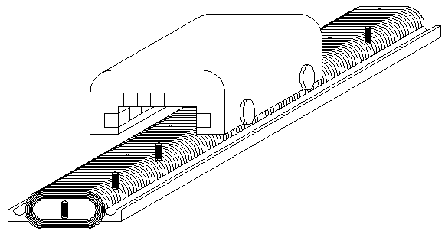
Figure 11 – Array of Inductors Inductrack Method

The array of inductor method utilizes an array of separate inductors. An example of an inductor is shown in figure 12.

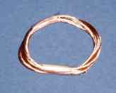
Figure 12 – Single Inductor

The thickness of the inductor needs to be significantly less than the wavelength of the Halbach array. The inductors must be wrapped around a nonferrous, non conductive material or the drag forces will be very large. This method is good for laboratory settings, because low levitation velocities can be acquired, but it is inefficient. Only about 1/6 of the magnetic field induced is used for levitation depending on the track parameters.

Wire Rungs
The wire rung method is currently being used for the Low-Speed Urban Maglev Program, because of its low cost and ease of production and manufacturing [5]. A wire rung track can be created by using bulks of insulated wire placed in rungs. The bulks of wire are Litz-wire that has been transposed, all wires reach the surface of the bulk of wires, and are pressed via rolling and specialized tapping into 2” square stainless steel tubes [6]. A smaller version of the square bulks is shown in figure 13.

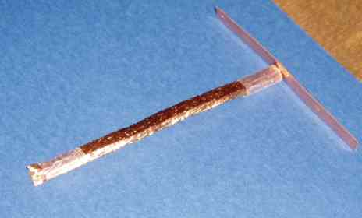
Figure 13 – Square Bulk of Copper Litz-wire

Stainless steel tubes provide structural support for levitating the train. The ends of the tubes, where the wires end, are soldered to copper strips to short the wires together. This creates the equivalent of laminated sheets of copper with grooves placed to guide the eddy currents. An illustration of the rungs is shown in figure 14.

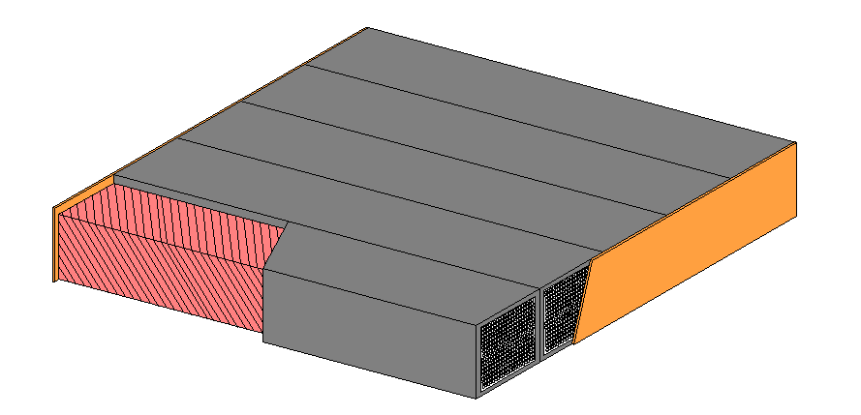
Figure 14 – Wire Rungs

Stainless steel tube exoskeletons are not needed if a different method is used for rails. A single rail, monorail, can be used with the levitation supported below the wire by bending it around the supporting structure. An illustration of this method is shown in figure 15.

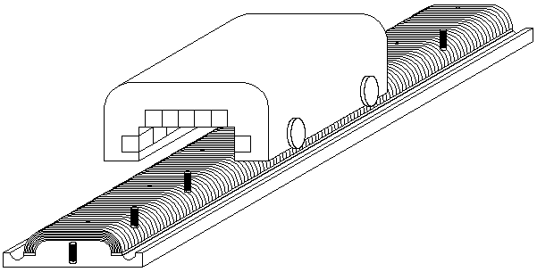
Figure 15 – Wire Rungs Inductrack Method

This method has been determined to be too expensive. The bulks of Litz-wire would cost $1,000 for a small test track. Normal bulks of wire which are not specially compacted may be used.

Laminated Sheets
The Laminated sheets method is created by laminating thin sheets of aluminum or copper together. The sheets must be bent to create lateral guidance. The sheets create large drag forces compared to the levitation forces at low velocities. The sheets can be chemically etched, or cut to create slots to guide the eddy currents. The specifications given by Richard F. Post for using chemically etched aluminum sheets as simulated by Lawrence Livermore National Laboratory are ten 0.5 mm thick sheets. The chemically etched slots would be 0.5 mm wide terminating 25 mm from the edge of the track. The lands between the slots would be 4 to 5 mm wide [7]. An illustration of the laminated sheet method is shown in figure 16.

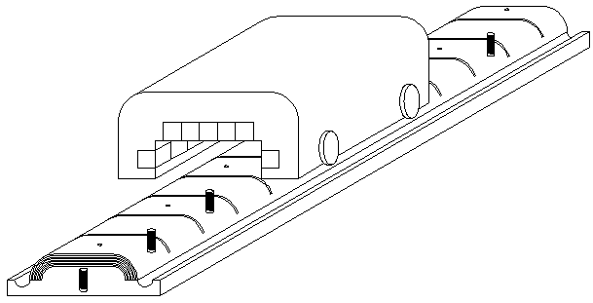
Figure 16 – Laminated Sheets Inductrack Method

The laminated sheet method has been found to create the largest levitation forces at high velocities, but requires a higher velocity to levitate. This is the method that the Low-Speed Urban Maglev Program is beginning to investigate.

Fabrication
The copper sheets were fabricated utilizing the design parameters. A computer numerically controlled (CNC) router at Midwestern Wood Products Co. was used to cut the grooves. A ‘V’ bit had to be used to cut the narrow groove to guide the eddy currents. Figure 17 shows the router bit used.

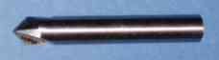
Figure 17 – CNC Router Bit

The fabrication of the track was very tedious. It is difficult to machine close narrow groves without tearing off the side pieces. Once created, pieces of paper were woven in between the grooves to insulate the conductive pieces from one another. A portion of the track created is shown in figure 18.

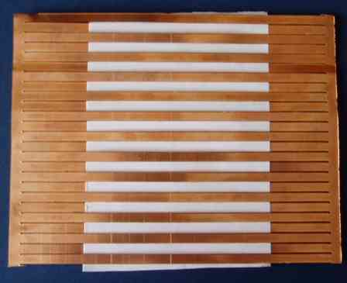
Figure 18 – Laminated Copper Sheet

Maglev System
The Halbach array and the Inductrack are used to create a Maglev system. The basics of the maglev system are illustrated in figure 19.

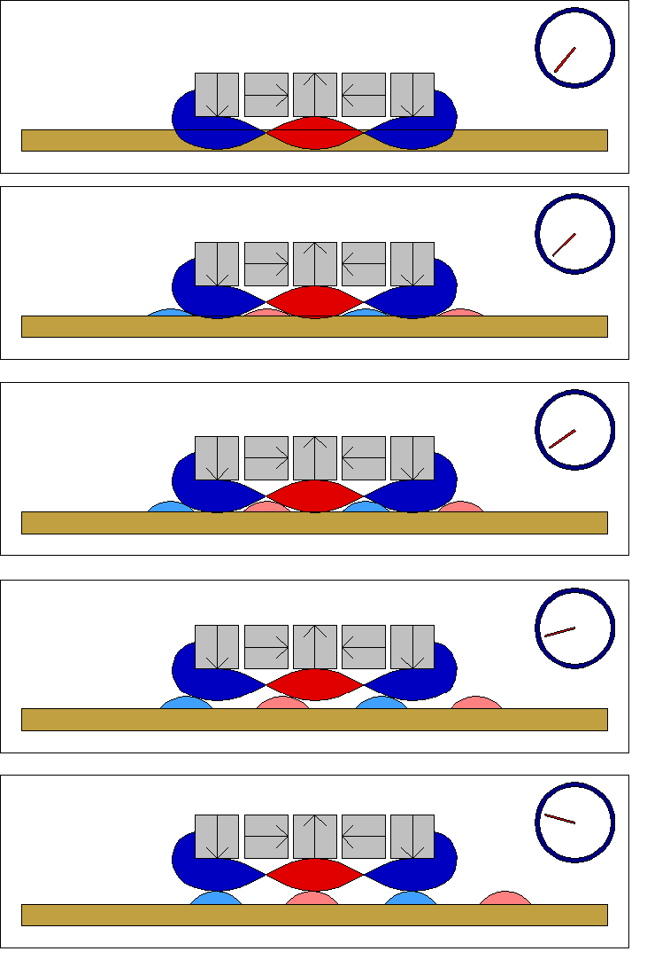
Figure 19 – Inductrack System Basic Illustration

The dial represents the speed or velocity of the Halbach array passing over the track. The red and blue portions represent the sinusoidal magnetic field below the Halbach array. The gold color is the track made of inductors. The light blue and red are induced magnetic fields created from the induced current in the track.

The stopped train does not induce current, or magnetic fields. As the train moves at slow velocities, small magnetic fields are produced with the like magnetic poles creating drag forces. When the velocity increases, the induced magnetic field becomes greater, thus causing more drag forces. Due to the inductance of the track, the phase of the induced current will begin to lag, or be delayed when the velocity or frequency reaches a certain point. As this happens, the like poles begin to line up under the Halbach array providing levitation. The maximum phase lag that can occur is 90º, which happens at high velocities.

Simulation
Vizimag has been used to simulate the Inductrack Maglev system. A cross sectional view of the system has been created by using magnets and powered inductor coils. The velocity of the Halbach array was simulated by creating a phase lag in the induced magnetic fields. The phase lag was manually created. Figure 20 shows the magnetic field simulations from a stopped position to a phase lag of 90º.

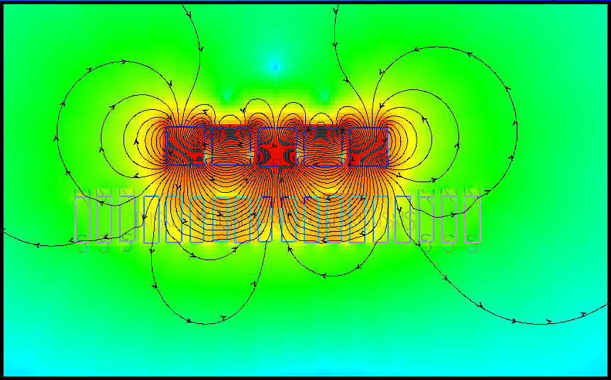
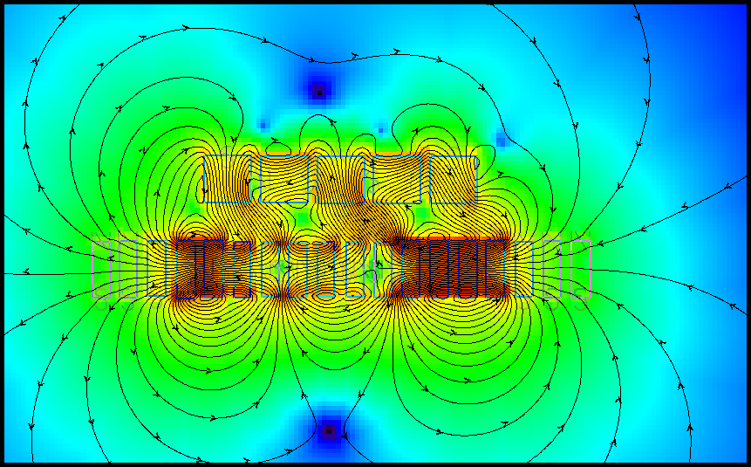
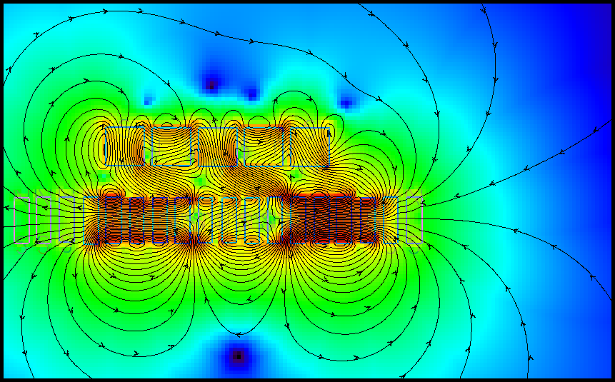
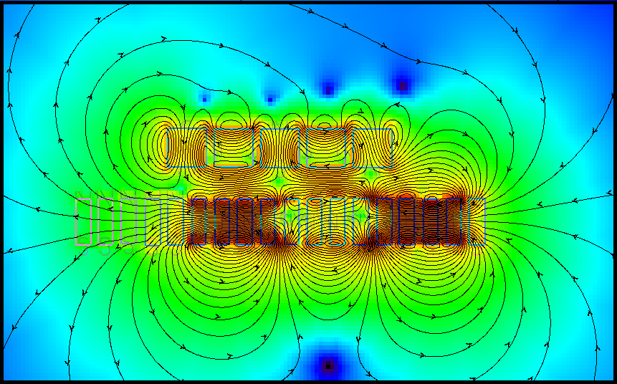
Figure 20 – Inductrack Maglev System Simulation

Figure 20 illustrates the conversion of drag forces into levitation forces as the phase changes from 0º to 90º.

Design Equations
The design equations to evaluate the Inductrack Maglev train system have been developed by LLNL. Equations have been compiled from many sources ([8][11][12]) into this document. The design can be placed into subcategories of train parameters, track parameters, breakpoint analysis, and transition analysis.

Train Parameters
Many variables are needed for the analysis of the train. The individual magnet’s strength is Br Tesla, and the thickness of each magnet d meters. The Halbach array will be created by M magnets per wavelength λ meters. When placed into the Halbach formation, the array will yield a peak strength shown by [11]

Bo = Br [1 – e ^{(- 4πd/λ)}] sin(π/M)/(π/M) Tesla (3)

The horizontal x and vertical y fields of the Halbach array which correspond with the Bx, magnetic drag, and By, magnetic levitation, are given by [11]

Bx = Bo sin(2πx/λ) e ^{[ -(2π/λ)(y)]} Tesla (4)
By = Bo cos(2πx/λ) e ^{[ -(2π/λ)(y)]} Tesla (5)

Levitation Halbach arrays in parallel will have the characteristics of a total width w meters, and a total length lm meters. Total levitation area A meters² is calculated by

A = w lm meters² (6)

Once a train is created, it will have a total mass tm kg. This mass is used to determine the force needed to levitate the train by

tf = tm (9.81 m/sec²) Newtons (7)

Train parameters are used with corresponding track parameters to create a Maglev train.

Track Parameters
The track can be created by using an array of inductors, wire rungs, or laminated sheets. The main track parameters are inductance and resistance. The “one turn equivalent” is used for the analysis of the track to create the greatest L/R ratio [8]. The greater the L/R ratio, the lesser the velocity required for levitation or an induced current phase shift.

Inductance
The distributed inductance Ld Henrys variables are dependent on the track type. Pc meters is the mean perimeter of the track, or the width of the track for the wire rung and laminated sheet methods. The conductor bundle height is ∆c meters, and the on center spacing of the inductors, bundles, or conductive strips is dc meters. Permeability of free-space μo is 4 π x 10⁻⁷ Henrys/meter is a constant needed for the for the calculation of the distributed inductance by [8][12]

Ld = μo Pc/ (4πdc/λ) Henrys (8)

It is noted that a disagreement was found for the Ld equation for a laminated sheet from [12]. The parameter w has been replaced by Pc in equation 8. The inductance can be increased by inductive loading without increasing the resistance of the track. This will lower the total levitation force as an end result. For all cases, the inductive loading depends on the conductor bundle height being loaded al meters, and the total width of the ferrite tiles used for loading h meters. The quantity of the effect of the ferrite tiles is [8]

Q = [e^{(πa/λ)} + e^{(-πa/λ)}]/[ e^{(πa/λ)} - e^{(-πa/λ)}] (9)

Utilizing Q, the added inductive loading is [8]

Ll = (h/Pc) (Q – 1) Ld Henrys (10)

The effect of the inductive loading on the total levitation force is the levitation scale factor shown by [8]

levsl = [Ld/(Ll + Ld)] = 1/[1 + h/Pc (Q -1)] (11)

levsl is used to scale the total force available. The total inductance is now given by [8]

L = Ld + Ll Henrys (12)

Resistance
The resistance of the track is a “one turn equivalent” resistance [8]. Therefore, all other turns, wires, or layers in a single inductor portion will act as resistors in parallel to lower the resistance of the track. The inductance of the track does not decrease in parallel as the resistance does, because the current is being induced throughout the inductor. The resistance rc ohms/meter of each single strand is utilized for the array of inductors track method as well as the wire rungs track method. The resistively rc μ p-l/A is utilized for the laminated sheet track method. The number of turns Nt and the number of strands per turn Ns is utilized for calculating the parallel resistance of each inductor for the array of inductor method and the wire rung method. Nt must be defined as the width of the inductor strip and Ns as the number of layers for the laminated sheet method. The resistance is given by

Array of Inductors & Wire Rungs [8]
R = rc Pc/(Nt Ns) Ohms (13)

Laminated Sheets
R = Pc rc/(Nt ∆c Ns) Ohms (14)

The R/L pole radians/second can now be found by taking the resistance and dividing it by the total inductance. The R/L pole yields the frequency in which the tracks induced current will lag by 45º. The drag forces will begin to greatly change to levitation forces one decade prior to the R/L pole. A high percentage of the force available will be levitation forces one decade after the R/L pole.

Inductrack Maglev System
Utilizing the train with the track, a Maglev system can be created. The train will need to roll at a given clearance y1 meters above the top of the inductor. The induced magnetic field of the track will be referenced from the middle of the upper inductor bundle. The levitation correction height is given by

Array of Inductors & Wire Rungs
levc = ∆c/2 meters (15)

Laminated Sheets
levc = ∆c*Ns/2 meters (16)

Utilizing levc, the corrected levitation height used for analysis is

yh = y1 + levc meters (17)

The frequency of the induced current is dependent on the velocity of the train or Halbach array passing over the track, where [8]

v = (λ/2π)(ω) meters/sec (18)
ω = 2v π/ λ rad/sec (19)

The speed of the train can also be converted for relative measurements to miles per hour by

s = v (100 cm/1 meter)(1 inch/2.54 cm)(1 foot/12 inches)(1 mile/5,280 ft) miles/hr (20)

It is noted that another scale factor must be considered. The fringe fields, ends, of the Halbach array will not produce the equal forces in comparison to the inner portions of the Halbach array. The scale factor can be found by determining the total number of current producing regions Is, two per wavelength. The fringe scale factor is given by

levs = 1 - (1/2Is) (21)

If fringe forces are ignored, levsf can be set to 1. It is also noted that the amount of levitation force used from the total induced magnetic field of the inductor is given by

levw = w/Pc (22)

A scale factor of the total force divided by the total available force is then given by

levsf = levs levsl levw (23)

The magnetic flux induced by each inductor of the track is given by [11]

φ = wBo/(2π/λ) e ^{(-2πy/λ)} sin(2πx/λ) [1 – e ^{(-2πy/λ)}] (24)

Utilizing the flux, the current induced by each portion of the track by passing the Halbach array over it is given by [11]

I(t) = (φ/L) [1/(1 + (R/ωL)²)] [sin(ωt) + (R/ωL)cos(ωt)] Amps/Circuit (25)

The current interacting with the magnetic field of the Halbach array will create a drag force, a levitation force, and a total force given by [11]

Fy = Iz Bx w Newtons/Circuit (26)
Fx = Iz By w Newtons/Circuit (27)
F = Iz w (Bx + By) Newtons/Cirucuit (28)

The average total force, levitation force <Fy> and drag force <Fx> per wavelength is given by the modified force equations [11] shown by

<F> = levs (λBo²w²/2πL)[(1+R/ωL)/(1 + (R/ωL)²)] e ^{(-4π y/λ)} Newtons/Circuit (29)
<Fy> = levs (λBo²w²/2πL)[ 1/(1 + (R/ωL)²)] e ^{(-4π y/λ)} Newtons/Circuit (30)
<Fx> = levs (λBo²w²/2πL)[(R/ωL)/(1 + (R/ωL)²)] e ^{(-4π y/λ)} Newtons/Circuit (31)

It is noted that the force constant is given by the modified equation [11] as
levs (λBo²w²/2πL) e ^{(-4π y/λ)} Newtons/Circuit (32)

The exponential portion of the equation accounts for the decrease in force as the train moves away from the track. The scale factor, levs, accounts for the reduced levitation force due to fringe effects. The phase shift associated with the drag forces shifting to levitation forces are given by

Fy Phase Shift = 90º - tan⁻¹(ω L/R) degrees/rad/sec (33)
Fx Phase Shift = tan⁻¹(ω L/R) degrees/rad/sec (34)

The Fy phase shifts from 90º to 0º, and the Fx phase shifts from 0º to 90º. Therefore, the phase shift distributes the total force created to the respective forces as a function of frequency. The induced current transfer function pole at R/L radians/second determines the frequency at which the phase shift occurs.

Summing the average forces and dividing by the area of the levitation Halbach arrays, the force per area is given by

Σ<F>/A = levs[Bo² w/(4πL dc/λ)] [(1+R/ωL)/(1 + (R/ωL)²)] e ^{(-4π y/λ)} Newtons/m² (35)
Σ<Fy>/A = levs[Bo² w/(4πL dc/λ)] [ 1/(1 + (R/ωL)²)] e ^{(-4π y/λ)} Newtons/m² (36)
Σ<Fx>/A = levs[Bo² w/(4πL dc/λ)] [ (R/ωL)/(1 + (R/ωL)²)] e ^{(-4π y/λ)} Newtons/m² (37)

Rewriting the force equations as a function of ω, the forces are

F(ω) = levs[Bo² w/(4πL dc/λ)] [(1+R/ωL)/(1 + (R/ωL)²)]A e ^{(-4π y/λ)} Newtons (38)
Fy(ω) = levs[Bo² w/(4πL dc/λ)] [ 1/(1 + (R/ωL)²)]A e ^{(-4π y/λ)} Newtons (39)
Fx(ω) = levs[Bo² w/(4πL dc/λ)] [ (R/ωL)/(1 + (R/ωL)²)]A e ^{(-4π y/λ)} Newtons (40)

The equations for the forces have been slightly modified, and rewritten as a function of s, where s is jω. The letter j is an imaginary number sometimes known as i. These equations are given by

F(s) = levs[Bo² w/(4πL dc/λ)] [L²s/(s + R/L)]A e ^{(-4π y/λ)} Newtons (41)
Fy(s) = levs[Bo² w/(4πL dc/λ)] [L²s²/((s – R/L)(s + R/L))]A e ^{(-4π y/λ)}Newtons (42)
Fx(s) = levs[Bo² w/(4πL dc/λ)] [jRLs/((s – R/L)(s + R/L))]A e ^{(-4π y/λ)} Newtons (43)

It is noted that the j will create a 90º phase shift.

By rewriting the force equations and setting y equal to the desired levitation height above the center of the upper inductor bundle, the frequency can be obtained for a given levitation height by

ω(y) = R/(L √{[( levs[Bo² w/(4πL dc/λ)]A e ^{(-4π y/λ)})/tf] – 1}) rad/sec (44)

The levitation height can be written as a function of frequency by

y(ω) = ln {(tf/(levs[Bo² w/(4πL dc/λ)] [ 1/(1 + (R/ωL)²)] A))} [λ/(-4π)] meters (45)

Dependent upon the R/L pole, the Lift/Drag ratio is given by [11]

Lift/Drag = <Fy>/<Fx> = ωL/R = (2πv/ λ)[L/R] (46)

The levitation efficiency is dependent on the amount of levitation force created in comparison to the power of the drag force produced given by [11]

K = <Fy>/<Fx>v = <Fy>/<P> = (2π/ λ)[L/R] Newtons/Watt (47)

Because the system is self stabilizing, there is a natural oscillation frequency shown by [12]

ω_{osc} = √[4πg/ λ] radians/second (48)

It is noted that g is 9.81 meters/second. The oscillation occurs at low frequencies, and decreases as the frequency increases. The train should roll on wheels during the peak frequencies of oscillation.

Breakpoint Analysis
The breakpoint velocity is defined as the velocity or frequency when the levitation force is great enough to levitate the train off its rolling clearance height y1. The parameters can be obtained by placing yh into all desired equations.

Transition Analysis
The transition velocity is defined as the velocity or frequency equal to the R/L pole. At this velocity, the phase of induced current is 45º, therefore the levitation force equals the drag force. At this velocity, the Maglev system becomes relatively efficient.

Analysis
The analysis of the parameters given in the design equations are evaluated for the created Maglev train. A MATLAB GUI has been created to calculate all parameters for all three track methods. The MATLAB GUIs for the three track methods are located in APPENDIX A, B, and C.

Laminated Sheets
The calculated outputs for the given inputs of the created Maglev train system are as follows:

Train/Magnet Parameters
Inputs:
Br 1.21 Tesla Magnet Strength
d 0.012 meters Magnet’s Thickness
M 4 magnets Magnets per Halbach Wavelength
λ 0.055 meters Halbach Wavelength
w 0.06 meters Width of Halbach Array
lm 0.06 meters Length of Halbach Array
tm 0.375 kg Total Train Mass
Outputs:
Bo 0.81281 Tesla Halbach Peak Strength
A 0.0036 m² Area Under Halbach Array
tf 3.6788 Newtons Force Required for Levitation

Track/Inductrack Parameters
Inputs:
∆c 0.0005334 meters Conductor Bundle Height
dc 0.0105 meters On Center Strip Spacing
Pc 0.11 meters Width of Track
rc 171.3 μ p-l/A Electric Resistively
Nt 0.005 meters Width of the Conductive Strips
Ns 1 layers Number of Laminated Layers
y1 0.01 meters Rolling Clearance about track
Inductive Loading
al 0.0005334 meters Conductor Bundle Height being loaded
h 0 meters Width of Ferrite Tile (Total)
Outputs:
Ld 5.7619e-8 Henrys Distributed Inductance “1 turn”
Ll 0 Henrys Added Inductance from Loading “1 turn”
L 5.7619e-8 Henrys Inductance “1 turn”
R 0.70652e-3 ohms Resistance “1 turn”
RLpole 12261.99 rad/sec R/L Pole
ω_{osc} 47.343 rad/sec Oscillation Frequency
v_{osc} 0.4144 meters/sec Oscillation Velocity
Break Point Analysis:
vb 23.2038 meters/sec Levitation Break Point Speed
sb 51.9054 miles/hour Levitation Break Point Speed
ωb 2650.7964 rad/sec Levitation Break Point Frequency
Fxb 17.0171 Newtons Drag Force at Break Point Speed
L2Db 0.21618 Break Point Lift to Drag Ratio
Transition Analysis:
vt 107.3356 meters/sec Transition Speed (Lift = Drag forces)
st 240.1029 miles/hour Transition Speed
ωt 12261.99 rad/sec Transition Frequency
Lht 0.020573 meters Levitation Height at Transition Speed
Fxyt 3.6787 Newtons Levitation Force and Drag Force
L2Dt 1 Transition Lift to Drag Ratio

The Halbach array created has the Bx, magnetic drag, and By, magnetic levitation, as shown in figure 21.

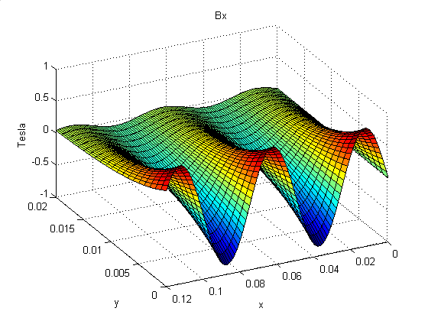
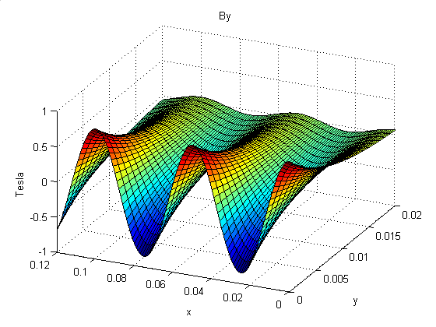
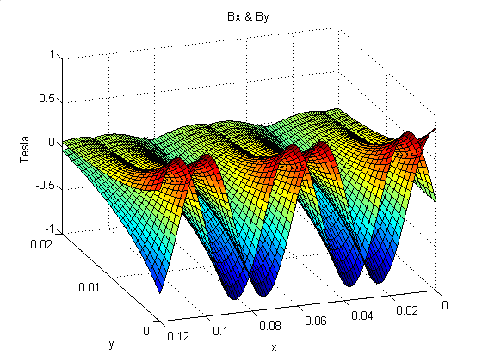
Figure 21 – Bx & By Components

Figure 21 illustrates the 90º phase difference between the drag forces and the levitation forces.

Levitation will occur at 23.2038 meters/second. The designed system is not efficient for low speeds. The transition velocity occurs at 107.3356 meters/second. The oscillation velocity peak occurs when the train is at velocities when it will still be rolling. The levitation and drag forces have been plotted in figure 22 as the velocity increases.

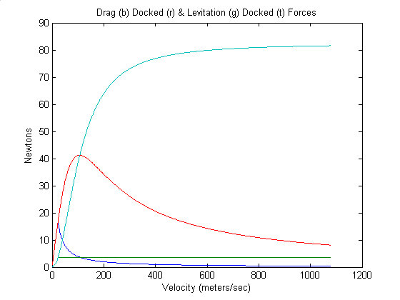
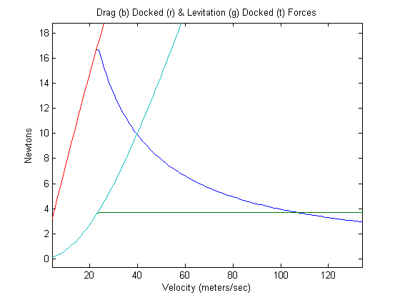
Figure 22 – Laminated Sheets Force Curves

The turquoise and red lines indicate the forces created if the train is fixed at a given height above the track. The green and blue lines indicate the forces created if the train rolls at its clearance level, and is then allowed to levitate. It is seen that when the train is allowed to levitate, the levitation force does not exceed the force needed to levitate the train as expected. When the train levitates, the drag forces decrease in comparison to the drag forces when it is fixed. As the velocity increases, the drag forces begin to decrease as the levitation forces begin to increase. The total levitation force at high velocities is 80 Newtons. The forces and phase shift are plotted with the velocity on a log scale in figure 23.

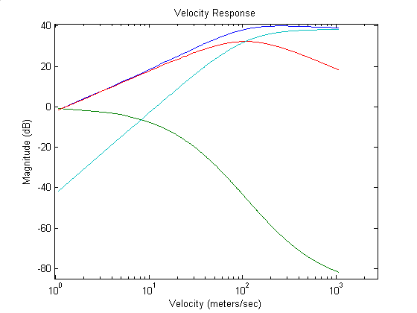
Figure 23 – Log Scale Forces and Phase Shift

The blue line represents the total force applied to the train. It is noted that the magnitude of the total force increases at ~20 dB/decade until it reaches the R/L pole, where it levels out. The red line represents the drag force which increases at 20 dB/decade and then decreases 20 dB/decade after the R/L pole. The turquoise line represents the levitation force which increases at 40 dB/decade and then levels out at the R/L pole. The green line represents the phase shift of the induced current. The middle of the phase shift is -45º located at the R/L pole. There appears to be two poles at R/L for the levitation and drag forces. This is because the inductor has a natural R/L pole, as well as the forces are converting from drag to levitation forces, centered around the R/L pole.

The levitation height relative to the top of the inductor is plotted in figure 24.

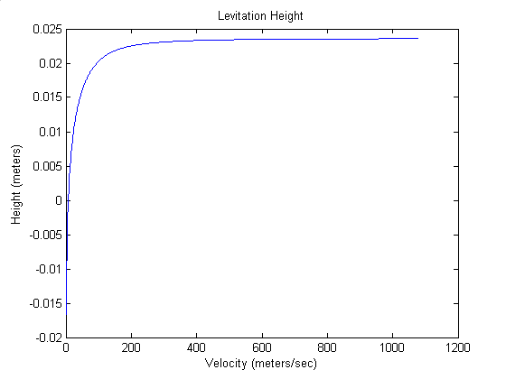
Figure 24 – Levitation Height

The height of levitation increases greatly as the drag forces shift to levitation forces, then levels.

Array of Inductors
Utilizing a theoretical array of inductors with the following parameters, another analysis has been made with the inputs and outputs as follows:

Train/Magnet Parameters
Inputs:
Br 1.21 Tesla Magnet Strength
d 0.012 meters Magnet’s Thickness
M 4 magnets Magnets per Halbach Wavelength
λ 0.055 meters Halbach Wavelength
w 0.06 meters Width of Halbach Array
lm 0.06 meters Length of Halbach Array
tm 0.375 kg Total Train Mass
Outputs:
Bo 0.81281 Tesla Halbach Peak Strength
A 0.0036 m² Area Under Halbach Array
tf 3.6788 Newtons Force Required for Levitation

Track/Inductrack Parameters
Inputs:
∆c 0.0125 meters Conductor Bundle Height
dc 0.016 meters On Center Inductor Spacing
Pc 0.40 meters Mean Perimeter of Coil
rc 1.36 ohms/m Strand Resistance
Nt 53 turns Number of Turns
Ns 150 strands Number of Strands per Turn
y1 0.01 meters Rolling Clearance about track
Inductive Loading
al 0.0125 meters Conductor Bundle Height being loaded
h 0 meters Width of Ferrite Tile (Total)
Outputs:
Ld 1.375e-7 Henrys Distributed Inductance “1 turn”
Ll 0 Henrys Added Inductance from Loading “1 turn”
L 1.375e-7 Henrys Inductance “1 turn”
R 6.8428e-5 ohms Resistance “1 turn”
RLpole 497.6558 rad/sec R/L Pole
ω_{osc} 47.3433 rad/sec Oscillation Frequency
v_{osc} 0.4144 meters/sec Oscillation Velocity
Break Point Analysis:
vb 5.7712 meters/sec Levitation Break Point Speed
sb 12.9099 miles/hour Levitation Break Point Speed
ωb 659.3048 rad/sec Levitation Break Point Frequency
Fxb 2.7768 Newtons Drag Force at Break Point Speed
L2Db 0.41442 Break Point Lift to Drag Ratio
Transition Analysis:
vt 4.3562 meters/sec Transition Speed (Lift = Drag forces)
st 9.7446 miles/hour Transition Speed
ωt 497.6558 rad/sec Transition Frequency
Lht 0.0089398 meters Levitation Height at Transition Speed
Fxyt 3.6787 Newtons Levitation Force and Drag Force
L2Dt 1 Transition Lift to Drag Ratio

The levitation velocity decreases greatly when the array of inductor method is utilized, as well as the total levitation force available. Figure 25 is the plot of the forces.

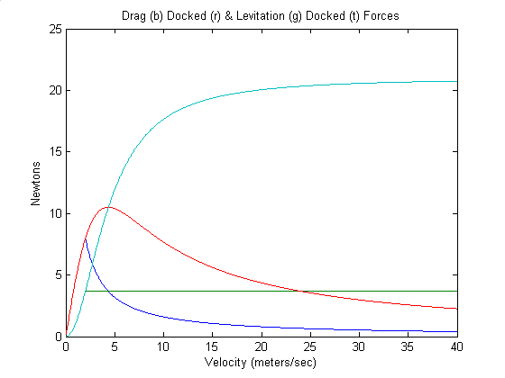
Figure 25 – Drag and Levitation Forces for Array of Inductors

The forces are similar to the forces found for the laminated sheets method, except all parameters are found at low velocities, and the forces are decreased. It has been found that the log scale plot and levitation height plot are proportional to the laminated track method as well. The array of inductor method is more efficient at low velocities due to the low R/L pole.

Wire Rungs
Utilizing the same input parameters of the array of inductors method, but using a Pc of 0.11 meters for the width of the track, the analysis of the wire rung method is as follows:

Track/Inductrack Parameters
Outputs:
Ld 3.7813e-8 Henrys Distributed Inductance “1 turn”
Ll 0 Henrys Added Inductance from Loading “1 turn”
L 3.7813e-8 Henrys Inductance “1 turn”
R 1.8818e-8 ohms Resistance “1 turn”
RLpole 497.6558 rad/sec R/L Pole
ω_{osc} 47.3433 rad/sec Oscillation Frequency
v_{osc} 0.4144 meters/sec Oscillation Velocity
Break Point Analysis:
vb 2.0076 meters/sec Levitation Break Point Speed
sb 4.491 miles/hour Levitation Break Point Speed
ωb 229.3518 rad/sec Levitation Break Point Frequency
Fxb 7.9823 Newtons Drag Force at Break Point Speed
L2Db 0.41442 Break Point Lift to Drag Ratio
Transition Analysis:
vt 4.3562 meters/sec Transition Speed (Lift = Drag forces)
st 9.7446 miles/hour Transition Speed
ωt 497.6558 rad/sec Transition Frequency
Lht 0.01459 meters Levitation Height at Transition Speed
Fxyt 3.6787 Newtons Levitation Force and Drag Force
L2Dt 1 Transition Lift to Drag Ratio

It is noted that the parameters that are not shown are the same as array of inductors method. The output parameters are similar to the array of inductors method except the force is greater for the wire rungs method, because a larger percentage of the track is used to levitate the track. A normal inductor wastes induced power by only utilizing the top leg of the inductor for levitation.

General Analysis
It has been found that the optimum magnet thickness, d, should be 0.25 λ. Knowing the weight of the magnets is proportional to the thickness d, equations 3 and 40 have been used to plot the maximum levitation height as the number of magnets and thickness increases shown in figure 26. The weight of the train increasing as the number of magnets increase, is accounted for in the plot. It is noted that the designed array of inductor method has been used to plot the optimum magnet thickness, because it yielded a greater variation for visual effect.

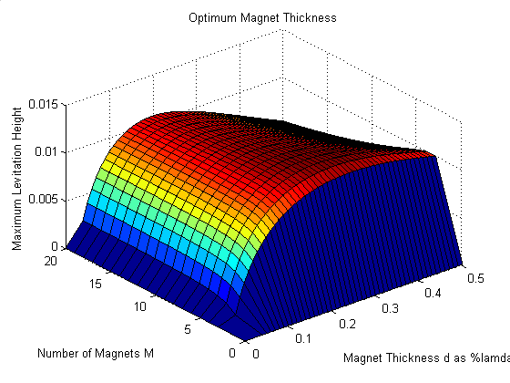
Figure 26 – Optimum Magnet Thickness

The peak levitation height occurred when M is 4 and d is 0.25 λ.

The maximum levitation height plotted as the number of magnets used in one wavelength increases is shown in figure 27. It was assumed that the optimum magnet thickness of 0.20 λ would be used.

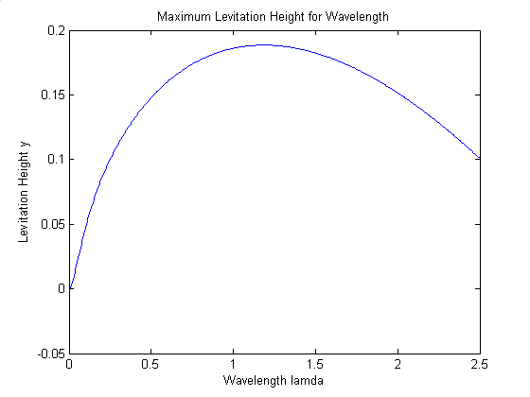
Figure 27 – Maximum Levitation Height and Wavelength

It is seen that a peak exists where the optimum wavelength can be obtained for the maximum levitation height. This wavelength may require the train to move at a higher velocity in order to levitate or become efficient.

Testing
In order to test the levitation portion of the Maglev system, a device must be created. The two methods are to create a straight track with the train moving over it, or create a wheel with the track wrapped over it and the train tethered above it as suggested by Dr. Post.

Straight Track
The straight track requires that a propulsion system be created to propel the train at a velocity high enough to levitate the train. This may be difficult if the train is heavy. Stopping the train may be difficult if the track is short. Another disadvantage of the straight track is the parameters can not be measured easily as the train is moving very quickly. A benefit of this method is that it is a good representation of what the track would actually look like.

Test Wheel
A disadvantage of the test wheel is it does not give a good visualization of the Maglev system working in normal operation. There are many advantages of using a test wheel. A small amount of track is needed to represent an infinite amount of track. Propulsion is not needed, the wheel spinning simulates propulsion, and train movement. No stopping method needs to be implemented. The greatest advantage is the drag and levitation parameters can be measured easily, because the train remains in one location. Due to the extra benefits of the test wheel, a Maglev Test Bench has been created using the test wheel concept.

Fabrication
The Maglev Test Bench has been created using a CNC router. Precision is necessary to create a round wheel to wrap the track around. Figure 28 shows the Maglev Test Bench.

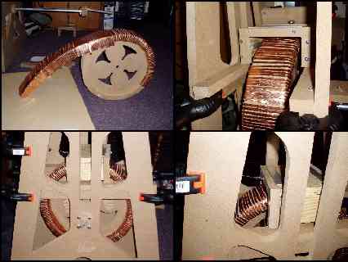
Figure 28 – Maglev Test Bench

A DC powered Pittman motor has been used to rotate the wheel with the track on it. Masking tape was used around the track to prevent the copper strips from flexing at high speeds.

Results
A frequency response has been taken of the track parameters by applying a function generator to it. It is noted that the frequency had to be scaled, because a resistor had to be placed in series in order to acquire accurate measurements. The frequencies were then converted to velocities. This data has been plotted against the predicted data shown in figure 29.

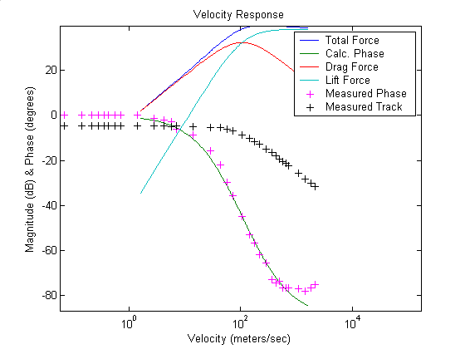
Figure 29 – Magnitude and Phase Shift

The phase matches the predicted phase shift curve with little error. The magnitude of the track parameters is used to show the pole location. This pole location matches with the predicted R/L pole location as well. The drag and levitation forces have been plotted as shown in figure 30.

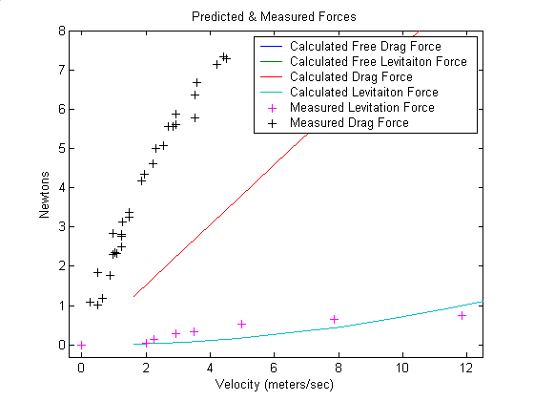
Figure 30 – Drag and Levitation Forces

As seen from the plot, the drag forces are very large in comparison to the levitation forces. The levitation forces matched closely to the calculated levitation forces. The drag forces were greater at lower velocities than the predicted forces. This could be an error in the measurement of the drag forces due to improper friction compensation. As the velocity increases, the drag forces will begin to drop, and the levitation forces will increase.

Propulsion
The Maglev Train system requires propulsion to be complete. A propulsion system has not been designed, but two methods are suggested. Propulsion can be implemented by the use of two main methods, a linear synchronous motor (LSM), and a linear induction motor (LIM).

Linear Synchronous Motor
The Low-Speed Urban Maglev Program is using the LSM method for propulsion and transverse guidance. This option was chosen due to the large air gap of 25 mm. An LSM is also cheaper for situations where more train cars are on the track. The use of an LSM creates a guidance force, and increases the passive levitation force. Three-phase windings of solid copper cables along laminated iron rails are placed along the track [12]. The three-phase windings being used are shown in figure 31.

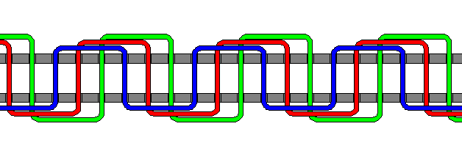
Figure 31 – Three Phase LSM Propulsion

The LSM creates a sinusoidal magnetic field which works with the sinusoidal fields of separate Halbach arrays to propel the train. LSM propulsion controls the velocity of the train by varying the frequency and amplitude. If improper control is used, the train will vibrate or “slip.”

Linear Induction Motor
An LIM can be used to levitate a system. LIM’s have conventionally been used by placing electromagnets inside the train portion of the system. The track is typically made of an aluminum ladder. When the train passes over a rung of the ladder, an electromagnet turns on, inducing a repulsive force in the track. This can both levitate, and propel the train. The same concept can be used by placing the electromagnets in the track. An illustration of this is shown in figure 32.

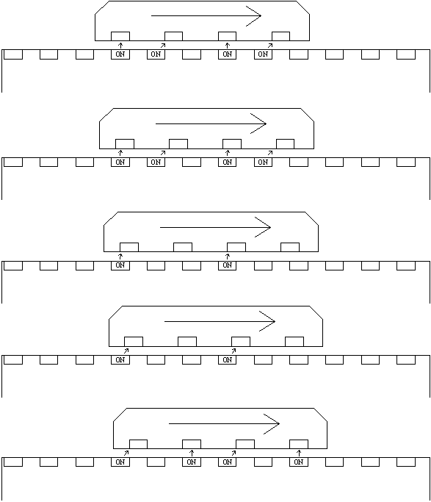
Figure 32 – Standard LIM Based in Track

A modified form of the LIM can be used to “tap” the train to propel it. This method would use the strong magnetic field present due to the levitation Halbach arrays. Electromagnets are evenly spaced along the track. A DC current is applied to the electromagnet when the back of the train is directly above it. The electromagnet is oriented so it will repel the Halbach array when turned on. When the back of the train passes over the next electromagnet the previous electromagnet turns off, and the next electro magnet turns on. The acceleration, and velocity can be controlled by the level of current, or duty cycle allowed into each electromagnet. An illustration of the modified LIM is shown in figure 33.

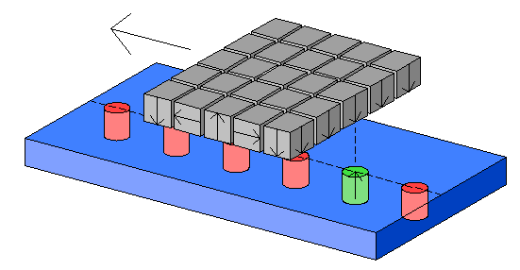
Figure 33 – Propulsion via Modified LIM

Both the LSM and the LIM propulsion method will require high power circuitry.

Conclusion
The Maglev Train 1 project utilized electrical engineering and physics concepts. Maglev systems using the Inductrack method avoid the use of complex control systems for stability. The fabrication of the Inductrack system is very difficult. The reduction of energy needed to operate the system offsets the fabrication difficulty in comparison to other Maglev methods.

Tradeoffs
Many tradeoffs have been determined for the Inductrack Maglev system. The tradeoffs are in regards to the speed at which the train will become efficient, and the levitation force provided by the system. The general tradeoff is that a greater inductance will create a lower R/L pole as seen by equations 31 and 32, which makes the train efficient at lower velocities, but the total force is decreases by a factor of the added inductance. Therefore, it is desired to achieve the greatest L/R ratio, but require a low L.

Using equation 8, it can be seen that increasing the mean perimeter or width of the track, increases the inductance of the track. The increase of Pc causes the percentage of the induced magnetic field used with the Halbach arrays for levitation to decrease as seen by equation 22. The increase of inductance will cause the train’s drag forces to become levitation forces at lower speeds. Because of this reason, the array of inductors method is good for a laboratory scale train, since the weight of the train should not be great, a low transition speed is the goal.

Inductive loading can be added to create a greater inductance. Equation 11 shows the scale factor. The inductive loading does affect the R/L pole to create a more efficient track.

The speed at which the train must travel to yield a greater frequency can be reduced by decreasing the wavelength as seen in equation 19. Decreasing the wavelength will decrease the levitation force available, and increase the rate of the exponential decrease in force as the levitation height increases as seen by equation 30.

Applications
Some possible applications of the Inductrack method are as follows:

Propulsion – linear synchronous motors (LSM) can utilize the magnetic field of Halbach arrays to propel an object along.

Generators – the Halbach array creates large amounts of current when passing across coils of wire.

Motors – Halbach arrays are utilized to create high power motors.

Bearings – the Inductrack method can be utilized to create near frictionless bearings.

Suspension – a magnetic suspension could be obtained by utilizing the Inductrack method.

Theories
The Inductrack method could be changed to create levitation with the object moving at a given velocity. This could occur if the Halbach array was placed in a circular formation with the sinusoidal magnetic field below the circle. A sunburst formation of wire rungs can be placed to allow the magnetic fields to cross the wire rungs perpendicularly. Figure 34 illustrates this method.

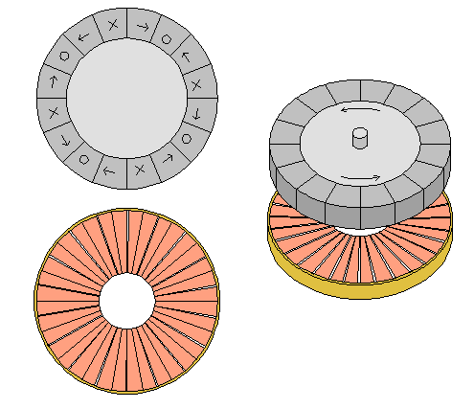
Figure 34 – Theoretical Static Movement

This method would allow for levitation, no lateral guidance, and no movement. Another wheel with a Halbach array could be placed below the wire rung section to allow for a centering levitation for suspension. If the object would need to be moved, a set up could be created as shown in figure 35.

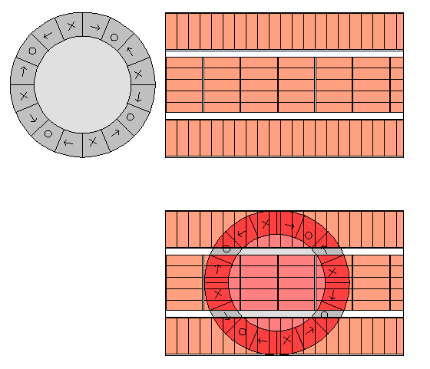
Figure 35 – Theoretical Dynamic Movement

This method attempts to place the rungs perpendicular to the movement of the spinning wheel, while allowing the wheel to move position laterally. Not all portions of the rungs will be perpendicular to the movement of the wheel, so drag forces will be created. If the wheel moves quickly in the horizontal direction, the middle section of the track will create drag forces. The middle portion could be eliminated if the force is not needed to levitate the object.

The system would be very efficient. There are no fringe forces, and the wheel could spin at a high velocity using low velocity. It would be difficult to precisely control the RPMs of the wheel, due to the nonlinear nature of the system. Precision control of the RPMs should not be needed for most applications.

Suggestions
A wire rung method should be used if the project is continued. This method would allow for the R/L pole to be at a lower velocity, but provide a great amount of levitation.

Equipment
Many parts had to be purchased for the creation of this project.

Products
The products obtained are as follows:

Vendor – Gaussboys, www.gaussboys.com
The NdFeB magnets are nickel plated, and grade N38.

40 – Block #05 - 12mm Cube Magnets $0.36/each $14.40 total
40 – Block #12 - 6mm Cube Magnets $2.25/each $90.00 total

Vendor – McMaster-Carr, www.mcmaster.com
Alloy 110 copper sheets are corrosion resistant, very ductile, and conductive. They are used for general purposes and electrical purposes. The copper may be used for track material.

1 - Part # - 8963K232 - 12” x 48”, 0.021” $25.00/each $25.00 total
2 - Part # - 8963K72 - 36” x 48”, 0.021” $54.55/each $109.10 total

Alloy 1100 Aluminum is “commercially pure.” It has the highest thermal and electric conductivity. The aluminum sheets may also be used for track material.

Vendor – Midwestern Wood Products Co., www.woodgrid.com
Midwestern Wood Products Co. of Morton, IL, has donated the wood and CNC router time to create the train and track.

Bradley University
One Pittman motor, and standard laboratory equipment have been used.

The total price of the project to Bradley University is $238.50.

Patents
Richard F. Post founded the Inductrack method, thus holds the patents on the levitation system. Two patents have been found to be issued.

Richard F. Post has been issued a patent for the Inductrack:

Richard F. Post
Magnetic Levitation System for Moving Objects
U.S. Patent 5,722,326
March 3, 1998

Richard F. Post
Inductrack Magnet Configuration
U.S. Patent 6,633,217 B2
October 14, 2003

Richard F. Post
Inductrack Configuration
U.S. Patent 629,503 B2
October 7, 2003

The laminated track design is currently patent pending:

Richard F. Post
Laminated Track Design for Inductrack Maglev System
U.S. Patent Pending US 2003/0112105 A1
June 19, 2003

The following are patents on various forms of LIMs and LSMs:

Coffey; Howard T.
Propulsion and stabilization for magnetically levitated vehicles
U.S. Patent 5,222,436
June 29, 2003

Coffey; Howard T.
Magnetic Levitation configuration incorporating levitation, guidance and linear synchronous motor
U.S. Patent 5,253,592
October 19, 1993

Levi;Enrico; Zabar;Zivan;
Air cored, linear induction motor for magnetically levitated systems U.S. Patent 5,270,593
November 10, 1992

The patents cover the basic methods of the Inductrack method. The Magnetic Levitation Technology 1 project will be utilizing these technologies to create a small scale system that might use a new concept that has not been used. Control methods for different properties of the system can be created as well.

Acknowledgments
Dr. Richard F. Post gave insight on the best way to create and test the Inductrack Maglev system. Midwestern Wood Products Co. of Morton Illinois made a large contribution by donating wood, and CNC router time to create the Maglev Test Bench. Dave Miller of Bradley University’s Mechanical Engineering Department helped by creating a motor couple for the Maglev Test Bench. Dr. Irwin and Dr. Schertz of Bradley University Department of Electrical and Computer Engineering helped with various portions of the project. A special thank you is given to Dr. Anakwa for his help throughout the entire project.

Bibliography

[1] Australian Magnetic Solutions (AMS), “Standard Grade Specifications for
Neodymium Iron Boron Rare Earth Magnets,” http://www.magneticsolutions.com.au/neodymium-specs.html, December, 2003.

[2] Halbach, K., “Applications of permanent magnets in accelerators and electron storage
rings,” Journal of Applied Physics, vol. 57, p. 3605, 1985.

[3] Harunur, Muhammad, Power Electronics, Circuits, Devices, and Applications

[4] Heller, Arnie. “Maglev on the Development Track for Urban Transport,” Lawrence
Livermore National Laboratory. November 2003.

[5] Jeter, Phil, Engineer at General Atomics, (Private Conversation)

[6] Marker, Hal, Litz-wire, (Private Conversation)

[7] Post, Richard F., (Private Conversation)

[8] Post, Richard F., “Inductrack Demonstration Model,” Report UCRL-ID-129664,
February 3, 1998.

[9] Post, Richard F., “Inductrack Magnet Configuration,” U.S. Patent No. 6,633,217 B2

[10] Post, Richard F., “Magnetic Levitation for Moving Objects,” U.S. Patent No.
5,722,326

[11] Post, Richard F., Ryutov, Dmitri D., “The Inductrack Approach to Magnetic
Levitation,” Lawrence Livermore National Laboratory.

[12] Post, Richard F., Ryutov, Dmitri D., “The Inductrack: A Simpler Approach to
Magnetic Levitaiton,” Lawrence Livermore National Laboratory.

[13] Post, Richard F. Gurol, Sam. Baldi, Bob. “The General Atomics Low Speed Urban
Maglev Technology Development Program.” General Atomics and Lawrence Livermore National Laboratory. 2003.

[14] Post, Richard F., Kratz, Robert, “Halbach Arrays for Maglev Applications,”
Lawrence Livermore National Laboratory. September 1999.

[15] Rizzoni, Giorgio, Principles and Applications of Electrical Engineering, 4th Edition

[16] Strubin, J. M., Veenstra, M., Rufer, A. “Linear Introduction Motor Demo-Track:
a Tool for Renewed Motivation in Electrical Engineering,”
APPENDIX A

Laminated Sheets Track Method MATLAB GUI Interface
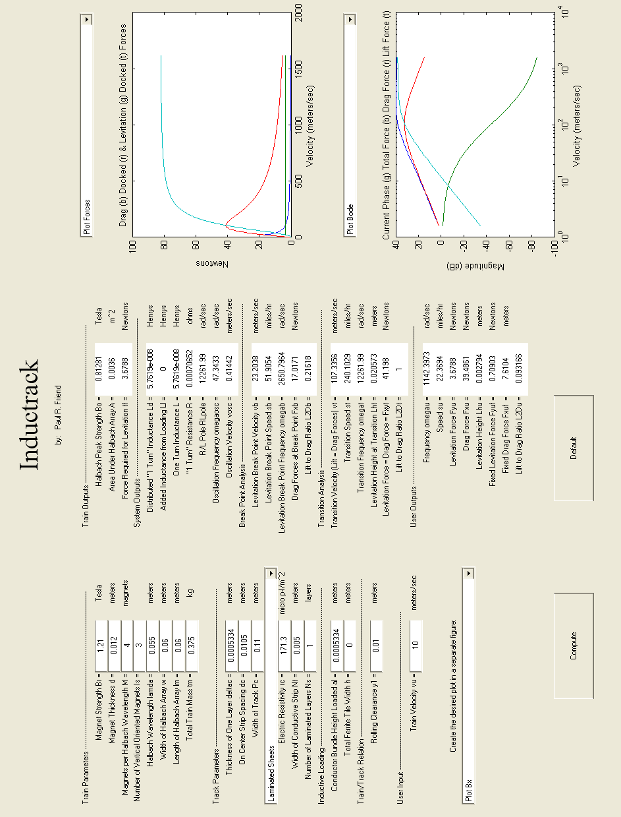

APPENDIX B

Wire Rungs Track Method MATLAB GUI Interface
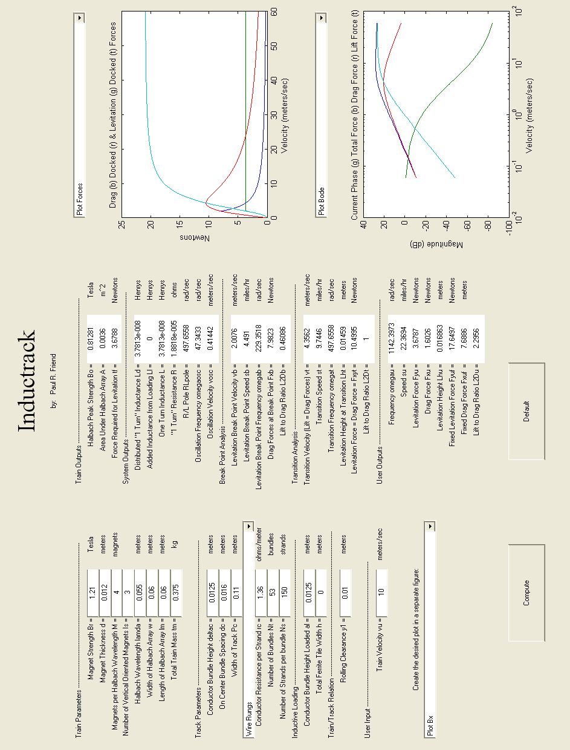

APPENDIX C

Array of Inductor Track Method MATLAB GUI Interface


